Welcome VM1s!

The SAVMA Bookstore will be hosting its annual Littmann Stethoscope Fair during the first or second week of school- exact date still to be determined. As the beginning of the school year approaches, an email with the date, time, and location will be sent out. During the fair, a McCoy Medical representative will be available for product demonstration and Q&A. Stethoscope order forms will be distributed at the event and are due the Monday after the stethoscope fair.

Common Q&A

Are stethoscopes required?
Stethoscopes are required for BMS 339 Clinical Foundations I. Stethoscopes will be used to perform physical examinations on live animals.

Am I required to purchase my stethoscope through the Bookstore?
No, you may use any source to purchase your stethoscope. However, students who purchase during the Stethoscope Fair receive discount pricing because of the bulk order.

If I am unable to purchase a stethoscope this fall, when is my next opportunity?
The Stethoscope Fair is an annual event.

Is a specific stethoscope type required?
No, however Classic III and Cardiology IV are the most popular models in veterinary medicine (see below).
https://www.youtube.com/watch?v=ytLGfpXbH6k&feature=youtu.be
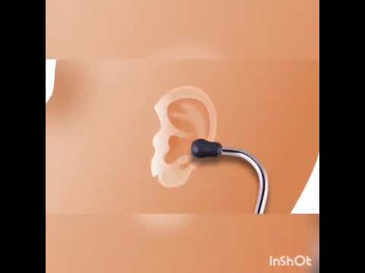 | Classic III School Video - YouTube  2 Hours Non Stop Worship Songs 2019 With Lyrics - Best Christian Worship Songs of All Time - Duration: 1:53:55. Worship Songs Recommended for you  www.youtube.com
https://www.youtube.com/watch?v=2Vk5RHjPBfo&feature=youtu.be
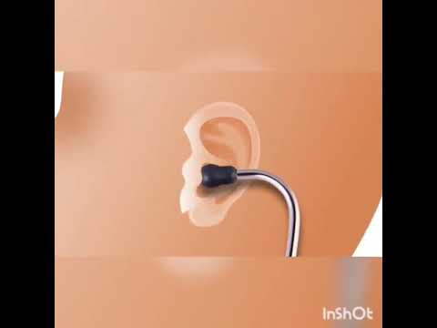 | Cardiology IV School Video  Cardiology IV  www.youtube.com
If you have further questions, please email us.

Thank you,

SAVMA Bookstore
Room #2246 Vet Med
1800 Christensen Drive
Ames, IA 50011-1134
(515) 294-9466
vetbooks@iastate.edu

